# Viewing Views - Explanation

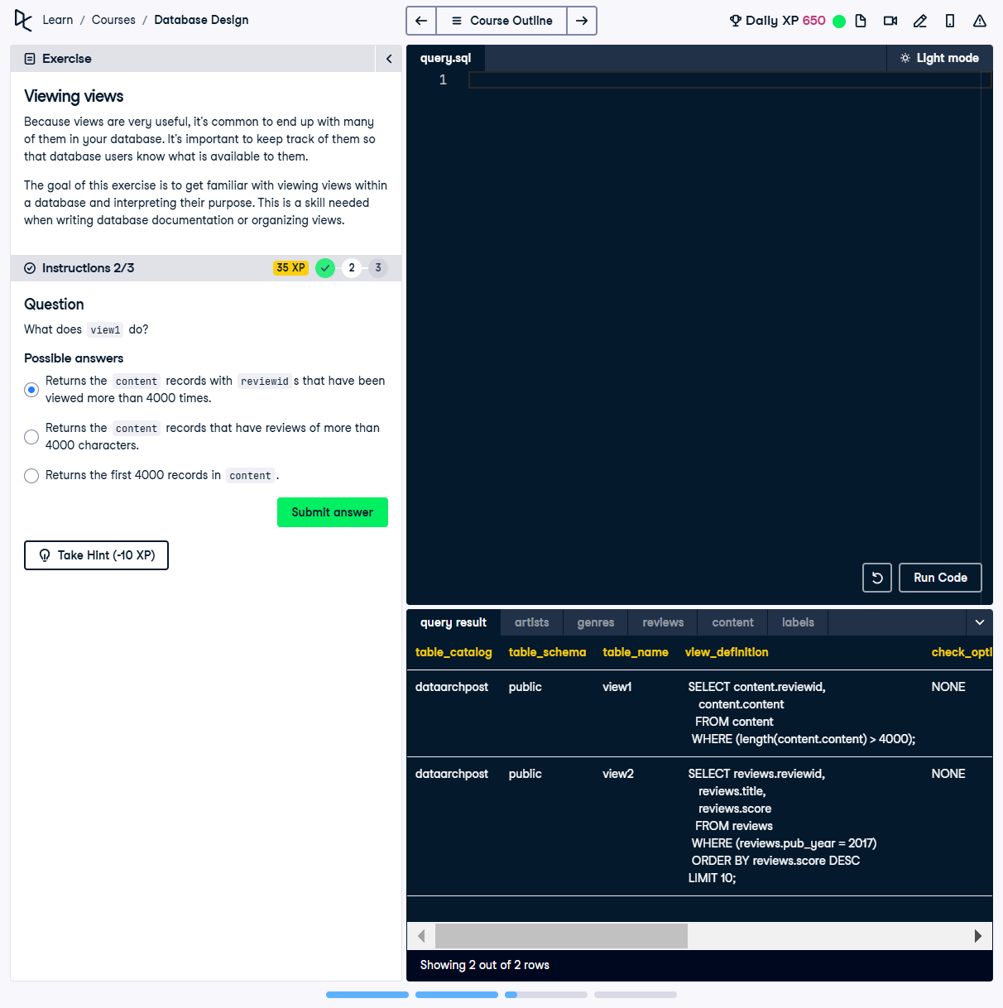

## Question

What does `view1` do?  
  
Possible answers:  
1️⃣ Returns the `content` records with `reviewid` that have been viewed more than 4000 times.  
2️⃣ Returns the `content` records that have reviews of more than 4000 characters.  
3️⃣ Returns the first 4000 records in `content`.

## ✅ Correct Answer

Returns the `content` records that have reviews of more than 4000 characters.

## Answer Explanation

🔹 The `view_definition` for `view1` is:  
```sql  
SELECT content.reviewid, content.content  
FROM content  
WHERE LENGTH(content.content) > 4000;  
```  
🔹 This means that `view1` retrieves **all `content` records where the length of the `content` field** is **greater than 4000 characters**.  
  
🔹 The **incorrect answers**:  
• The first option mentions `reviewid` viewed more than 4000 times, but this view does **not track view counts**.  
• The third option talks about returning the first 4000 records, but `LIMIT 4000` is **not present** in the query.